

By: Americo Marcos

Case study: How does a bike-share navigate speedy success?

Introduction to Cyclistic bike-share

In 2016, Cyclistic launched a successful bike-share offering . Since then, the program has grown to a fleet of 5,824 bicycles that are geo-tracked and locked into a network of 692 stations across Chicago. The bikes can be unlocked from one station and returned to any other station in the system anytime.

Until now, Cyclistic’s marketing strategy relied on building general awareness and appealing to broad consumer segments. One approach that helped make these things possible was the flexibility of its pricing plans: single-ride passes, full-day passes, and annual memberships. Customers who purchase single-ride or full-day passes are referred to as casual riders. Customers who purchase annual memberships are Cyclistic members.

Cyclistic’s finance analysts have concluded that annual members are much more profitable than casual riders. Although the pricing flexibility helps Cyclistic attract more customers, Moreno believes that maximizing the number of annual members will be key to future growth. Rather than creating a marketing campaign that targets all-new customers, Moreno believes there is a solid opportunity to convert casual riders into members. She notes that casual riders are already aware of the Cyclistic program and have chosen Cyclistic for their mobility needs.

Moreno has set a clear goal: Design marketing strategies aimed at converting casual riders into annual members. In order to do that, however, the team needs to better understand how annual members and casual riders differ, why casual riders would buy a membership, and how digital media could affect their marketing tactics. Moreno and her team are interested in analysing the Cyclistic historical bike trip data to identify trends.

The director of marketing believes the company’s future success depends on maximizing the number of annual memberships. Therefore, the team wants to understand how casual riders and annual members use Cyclistic bikes differently. From these insights, the team aims design a new marketing strategy to convert casual riders into annual members. But first, Cyclistic executives must approve my recommendations, so they must be backed up with compelling data insights and professional data visualizations.

Characters and teams

**Cyclistic:** A bike-share program that features more than 5,800 bicycles and 600 docking stations. Cyclistic sets itself apart by also offering reclining bikes, hand tricycles, and cargo bikes, making bike-share more inclusive to people with disabilities and riders who can’t use a standard two-wheeled bike. The majority of riders opt for traditional bikes; about 8% of riders use the assistive options. Cyclistic users are more likely to ride for leisure, but about 30% use the bikes to commute to work each day.

**Lily Moreno:** The director of marketing and the manager. Moreno is responsible for the development of campaigns and initiatives to promote the bike-share program. These may include email, social media, and other channels.

**Cyclistic marketing analytics team:** A team of data analysts who are responsible for collecting, analysing, and reporting data that helps guide Cyclistic marketing strategy.

**Cyclistic executive team:** The notoriously detail-oriented executive team will decide whether to approve the recommended marketing program.

**Ask phase**

Below are three questions that will guide the future marketing program:

* + How do annual members and casual riders use Cyclistic bikes differently?
  + Why would casual riders buy Cyclistic annual memberships?
  + How can Cyclistic use digital media to influence casual riders to become members?

Mister Moreno the Director of marketing and the manager has assigned me with first question to answer:

* How do annual members and casual riders use Cyclistic bikes differently?

**Clear statement of the business task**

A clear statement of this case study is to explore ways in which the company can maximise the number annual members in order to achieve success in the future. By doing so, it is extremely crucial for the team to be on the same page and comprehend how casual riders and annual members make use of Cyclistic bikes directly.

A description of all data sources used

Prepare

The data source used for this case study are provided by Cyclistic’s historical trip data to analyse and identify trends, which are made available and can be downloaded on their website, the link in order to access their datasets is the following: <https://divvy-tripdata.s3.amazonaws.com/index.html>

For the purposes of this case study, the dataset is appropriate and will be enough to answers the questions identified previously. The data has been made available by Motivate International Inc. This is public data that can be used to explore how different customer types are using Cyclistic bikes, keeping in mind that data-privacy issues prohibition from using riders’ personally identifiable information. This means that I will not be able to connect pass purchases to credit card numbers to determine if casual riders live in the Cyclistic service area or if they have purchased multiple single passes.

**Process**

After the dataset was downloaded, a folder was created on the desktop and an appropriate name was given to it, the data was Launched on Excel, and saved as an Excel Workbook. I performed the cleaning process on excel as well as sorting and filtered the data, I also checked for blanks, Then I checked for duplicate values and no duplicates were removed.

I also adjust the cells so that all the values can fit perfectly by selecting the all table and by clicking on formatting in order to autofit rows and columns hight and length. I transformed the dataset into a table so it can look more aesthetically pleasing, and finally, rows with data not in the correct format were deleted. After cleaning using Excel I continued continue the analysis on excel as well.

**Analyses ||** Documentation of any cleaning or manipulation of data

After analysing the data on a spreadsheet, I created a column called **ride_length** in order to calculate the length of each ride by subtracting the column from the column **ended_at** and I made used of the following formula (=D2-C2) and formatted as HH:MM:SS using Format > Cells > Time > 37:30:55. I Created a column called **day_of_week** , and calculated the day of the week that each ride started using the command **(=Weekday(C2,1))** in each file. The format used was as a number with no decimals, keeping in mind that 1 stands for Sunday and 7 stands for Saturday as it shows in the images below.

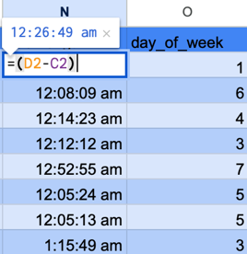 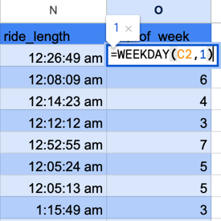

Conduct descriptive analysis.

In order to gain a deeper insight into the Cyclistic bike-share data, I conducted a few calculations in order to uncover key statistics that can inform operational decisions. These calculations included determining the mean and maximum values of ride_length, as well as identifying the mode of Day_of_week. Each of these metrics provides valuable insights into user behaviour and operational performance.

Firstly, by calculating the mean ride_length, we can understand the average duration of trips taken by Cyclistic users which is actually 16 minutes and 22 seconds. This metric is crucial for several reasons.

In addition to the mean ride_length, analysing the maximum ride_length provides insights into the longest trips taken within the dataset which equals to 18 hours and 40 minutes. Understanding the extremes of user behaviour helps in identifying potential outliers or unusual patterns.

Furthermore, determining the mode of Day_of_week sheds light on the most popular day for bike usage. This metric is particularly useful for operational planning and resource allocation.

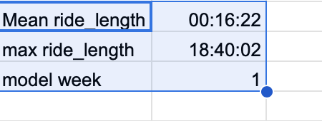

By combining these insights, Cyclistic can make informed decisions that enhance operational efficiency and improve customer satisfaction. Understanding the average and maximum ride lengths, along with the most popular days for bike usage, enables the company to optimize bike availability, plan maintenance effectively, and tailor marketing efforts to user preferences. These calculations are just the beginning of a comprehensive data analysis that can drive Cyclistic's growth and success in the competitive bike-share market.

I wanted to know the exactly gap between the number of members and casual riders, so I used the countIf functions to get the number of times the word members appear on the column **member_casual**, I used the same formula in order to get the casual riders as well as the total numbers of riders. In order to make it more aesthetic I used the bar chart for the visualization

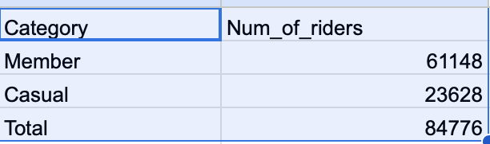

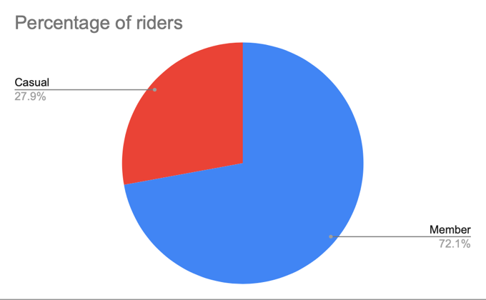

As we can observe, 84,776 make up the total number of riders in the Cyclistic bike-share program. Within this total, only 27.9% are casual riders, which translates to approximately 23,644 individuals. This leaves a significant gap when compared to the remaining 72.1%, or approximately 61,132 riders, who are presumably annual members. This discrepancy highlights a notable opportunity for growth in the casual rider segment.

The 44.2% gap between casual riders and annual members signifies a substantial potential market that Cyclistic can tap into. By understanding the preferences and behaviours of these casual riders, Cyclistic can tailor their services to better attract and convert them into more frequent users or even annual members. This could involve implementing targeted marketing campaigns, offering incentives for repeat rides, or introducing flexible membership options that cater to the casual rider's needs

I also calculated the average **ride_length** for members and casual riders by creating a pivot table and visualize the data

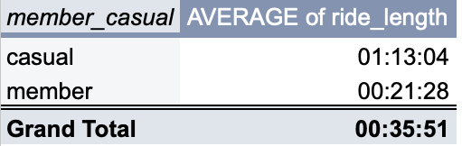

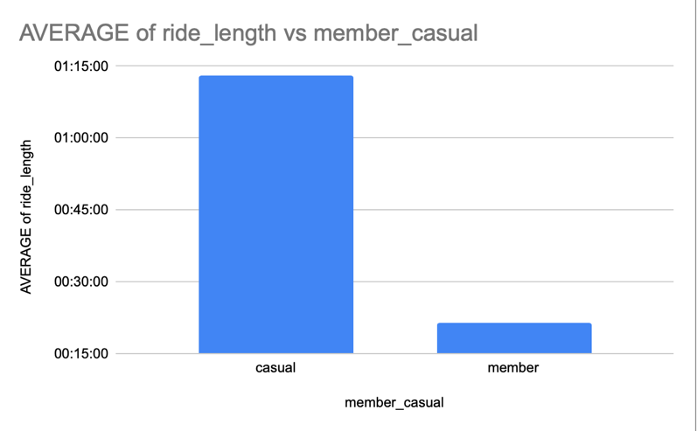

We can observe that casual members ride for the longest duration, averaging 1 hour and 14 minutes per ride, with a obvious contrast to members, who average a total of only 21 minutes per ride, can be attributed to several factors.

Firstly, the nature of casual riders' usage patterns significantly differs from that of members. Casual riders, often tourists or occasional users, are more likely to engage in leisurely rides, exploring the city at a relaxed pace. They might use the bikes for sightseeing, weekend getaways, or exploring new areas, which naturally results in longer ride durations. This could be the reason why usage aligns with the longer average ride time of being 1 hour and 14 minutes.

In contrast, members are typically daily commuters or residents who use the bike-share system for practical purposes, such as commuting to work, running errands, or quick trips around the city, focused on efficiency and convenience, leading to shorter ride times.

Moreover, the pricing structure of bike-share programs often influences ride durations. Casual riders usually pay per trip or per hour, which might encourage them to maximize their time on the bike within a single rental period

I also calculate the amount of rides being taken each day of the week, which days are the busiest and the least busy days. The visualisations below can tell a better story



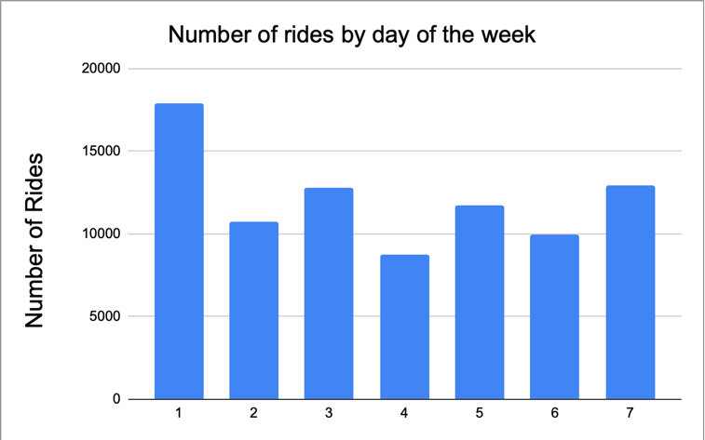

Sunday and Saturday are the busiest days for Cyclistic bike-share, which is not surprising given that these days fall on the weekend when most people engage in leisure or free-time activities. This increased activity during the weekends. Weekends provide people with more free time away from work or school, allowing them to indulge in recreational activities. Many individuals and families use this time to explore the city, visit parks, or participate in outdoor events, which naturally leads to higher bike usage. Cyclistic bikes offer a convenient and enjoyable way to navigate the city, making them a popular choice for weekend outings.

Moreover, the pleasant weather during weekends, especially in spring and summer, encourages people to spend time outdoors. The flexibility of bike-share programs allows users to spontaneously decide on a bike ride, contributing to the surge in usage on Saturdays and Sundays. Cyclistic could capitalize on this trend by organizing weekend-specific promotions, such as discounts for extended rides or special weekend passes, to further boost usage

I wanted to know which day of the week average the longest rides, so I created a pivot table which displays below.

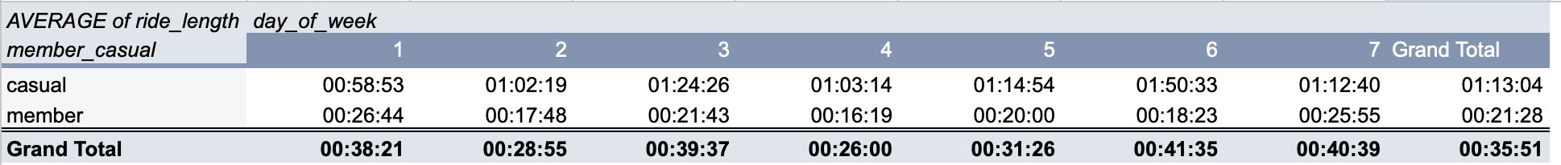

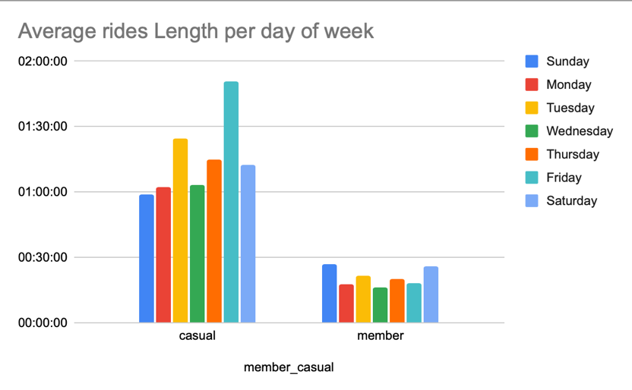

It turns out that Fridays average the longest trips taken by casual riders, while Sundays see the longest rides taken by member riders, with Sundays slightly edging out Fridays. This observation reveals interesting patterns in user behaviour that Cyclistic can leverage to enhance service offerings and user satisfaction.

Share

For casual riders, the extended ride times on Fridays can be attributed to the transition from the workweek to the weekend. Many casual riders might begin their leisure activities early, taking advantage of the end-of-week relaxation to explore the city, unwind, or socialize with friends. The longer rides on Fridays suggest that casual riders are using the bike-share system not just for transportation, but as part of their recreational activities.

Sundays being the peak day for longer rides among member riders indicates a trend towards weekend leisure and fitness activities. Members, who are likely more familiar with the bike-share system and may use it regularly, might prefer Sundays for longer, more relaxed rides. This could be due to reduced traffic, more available time, and the general culture of using Sundays as a day of rest and recreation.

Recommendations

Cyclistic can capitalize on this by offering special Friday evening promotions, such as discounted rates for longer rides or group ride packages, encouraging even more users to start their weekends with a bike ride. By promoting and enhancing the biking experience on Fridays and Sundays, Cyclistic can maximize user engagement and satisfaction, which tend convince casual riders to become members.

By enhancing weekend offerings and especially on days which casual riders take the longest and the most bike trips can influence casual riders to become a Cyclistic bike-share , member. Cyclistic can optimize bike availability and increase overall usage across all days of the week. This strategic approach ensures that Cyclistic meets the varying needs of its users, enhancing user satisfaction and promoting the growth of the bike-share program.

For example, extremely long ride lengths might indicate issues such as bikes being forgotten or stolen, or they could highlight a subset of users who enjoy long-distance biking. Addressing these outliers can improve the overall user experience by ensuring bikes are returned promptly and reducing the likelihood of theft.

Cyclistic can also ensure that more bikes are available in high-demand areas during busiest times. Additionally, this information can be used to plan maintenance schedules, ensuring that bikes are serviced and ready for peak usage periods.